# **Neural Network Layer**

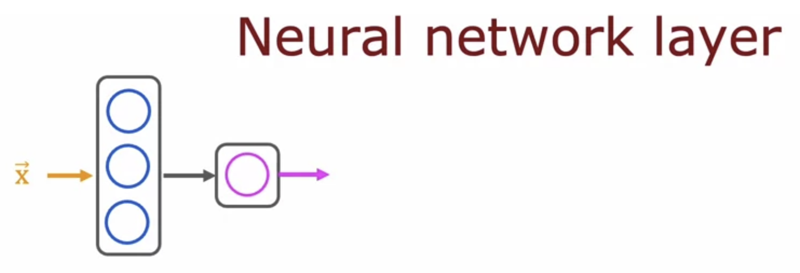

0th layer 🡪 Input X

1st Hidden Layer

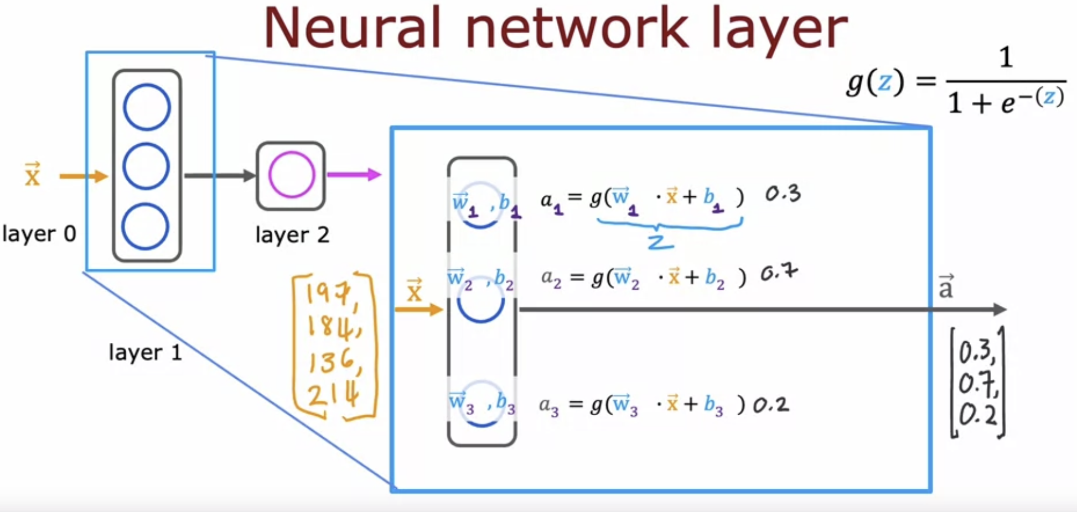

For a single hidden input layer the sub-script notation is fine.

But what for >1 hidden layer 🡪 Here comes the super-script

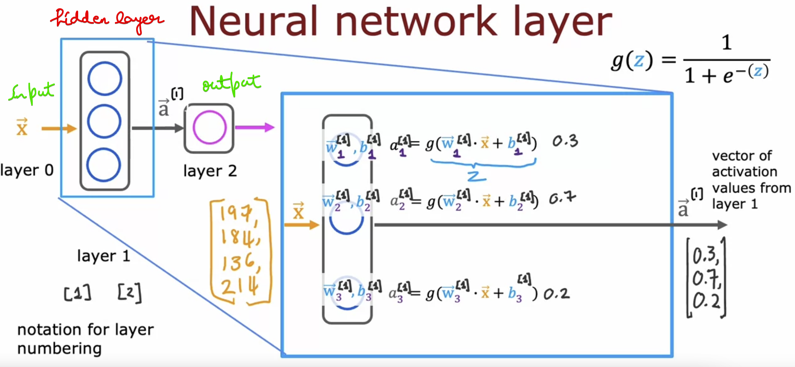

Super-script [1] 🡪 1st hidden layer

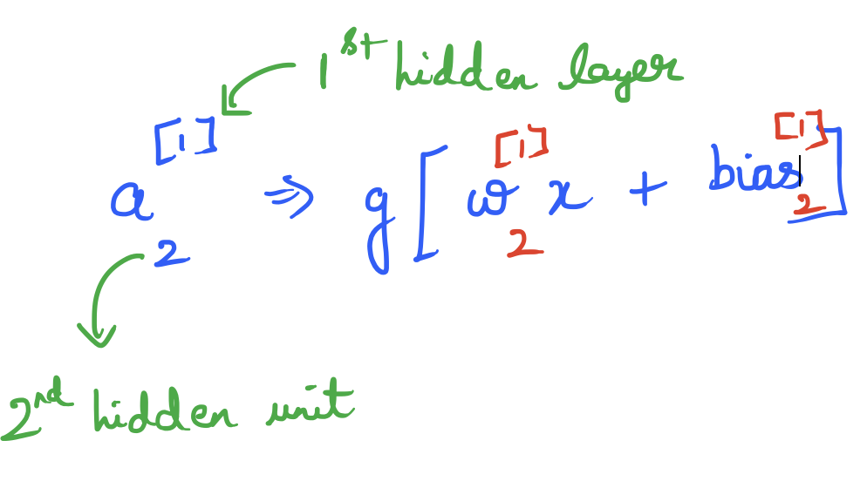

2nd Hidden Layer   
Output of 1st hidden layer will be the input to the 2nd hidden layer

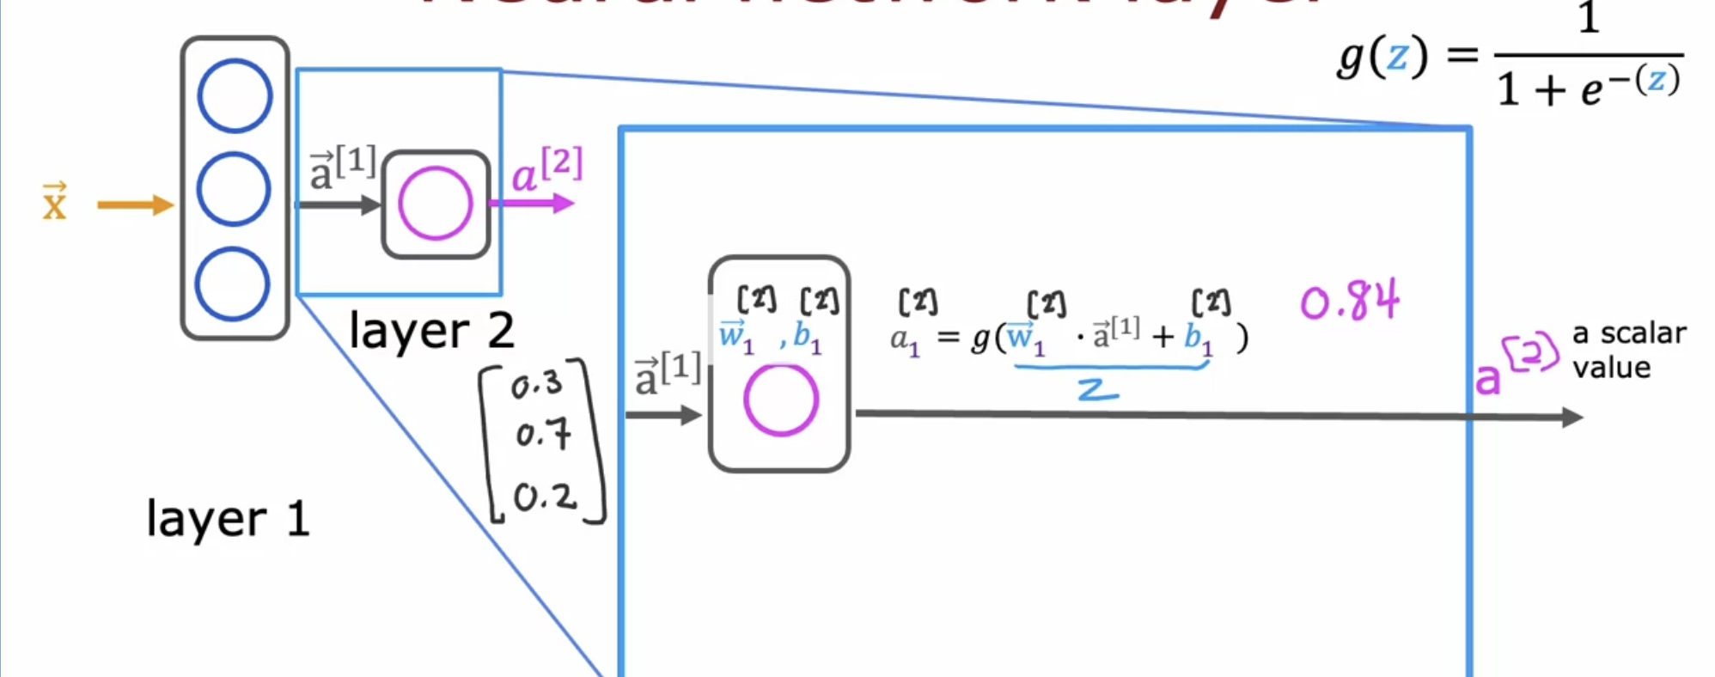

Over-all summary

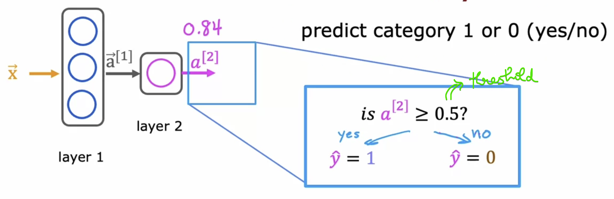

# **More Complex Neural Network Layer**

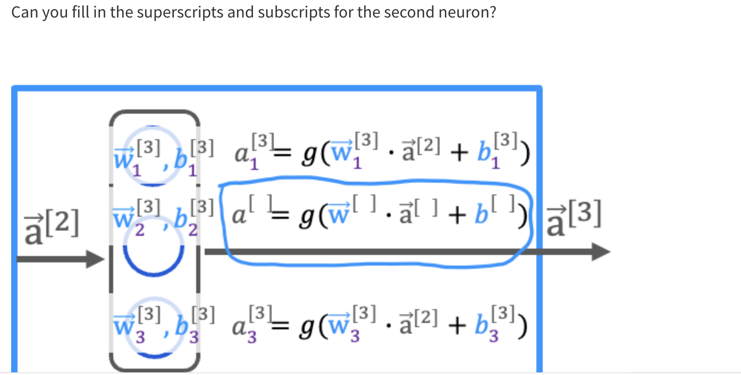  
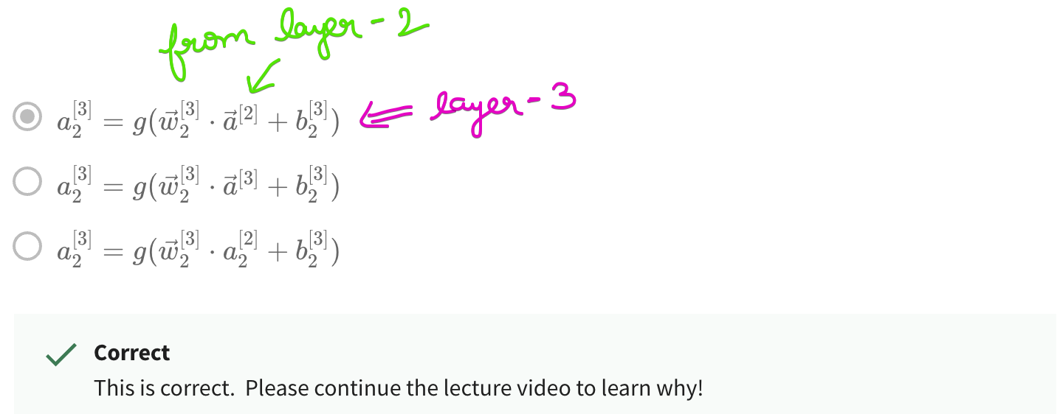

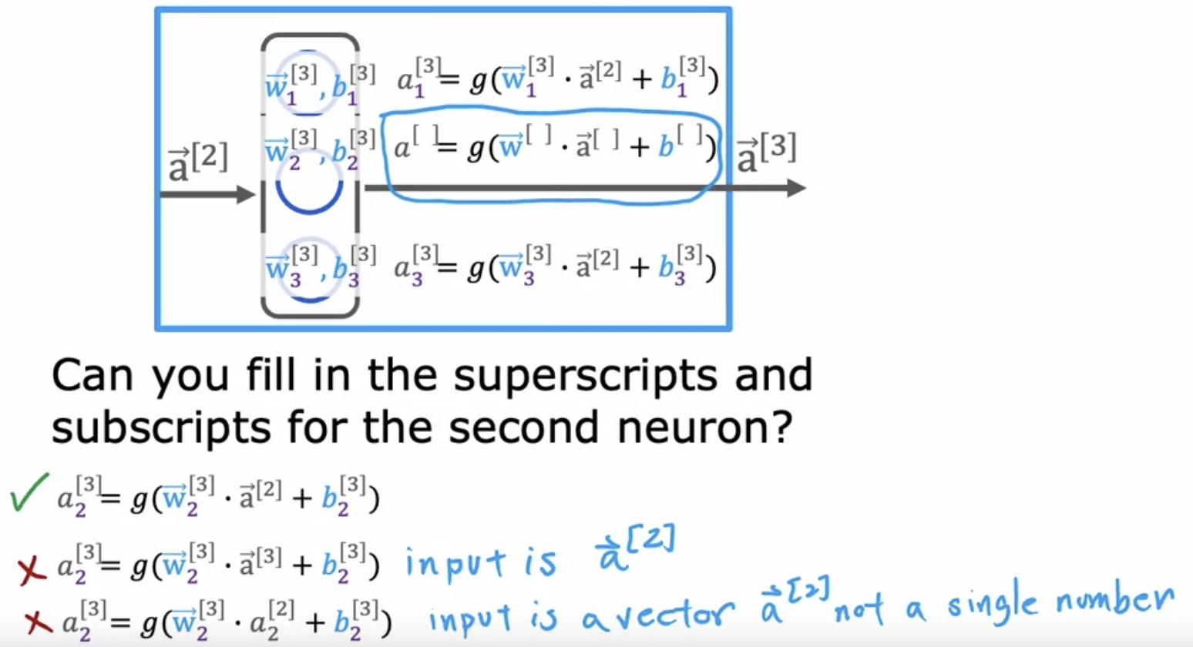

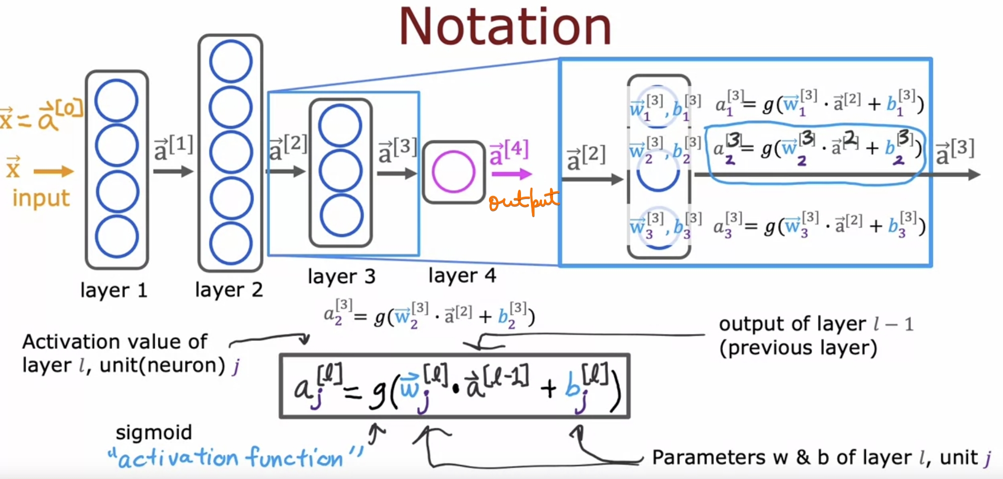

# **Inference : Making predictions**

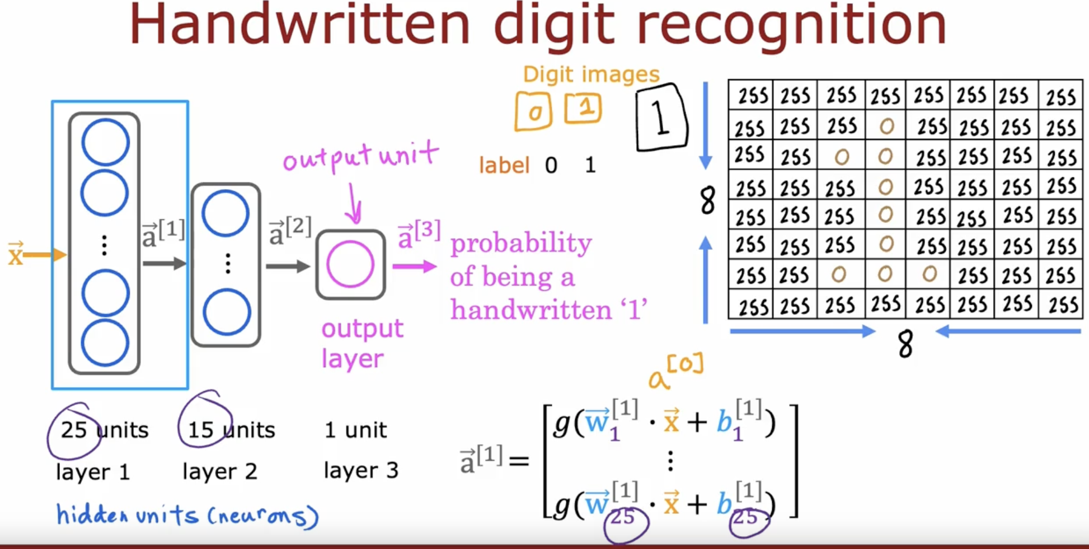  
Layer-1 🡪 15 units

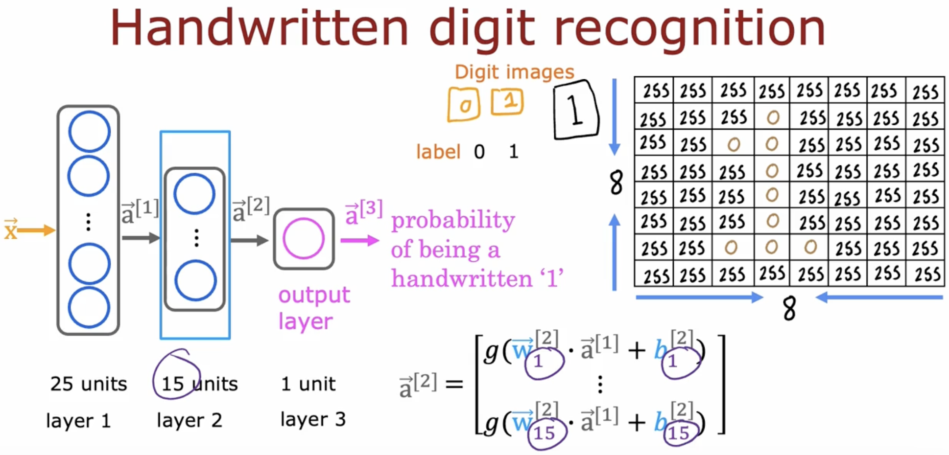

Layer-2 🡪 15 units

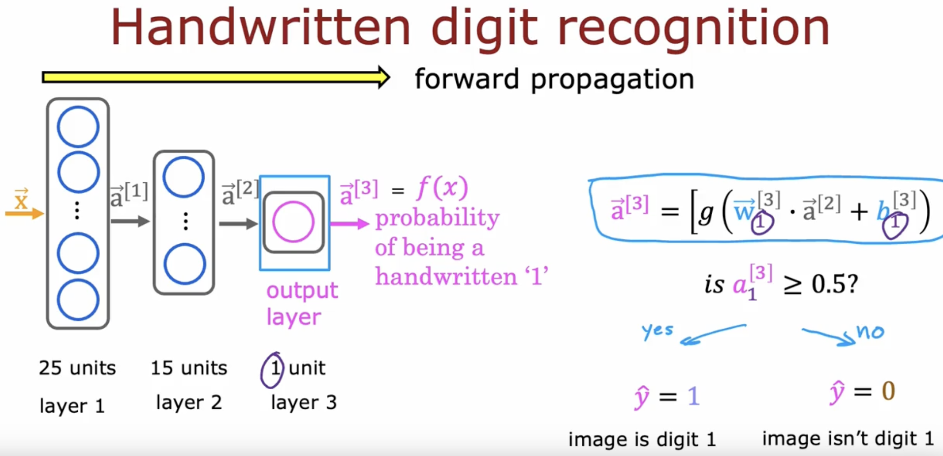  
Layer-3 🡪 1 unit

# **Neurons and Layers**

Refer 1_Neurons_and_Layers.ipynb

# **Quiz**

